**Alert**

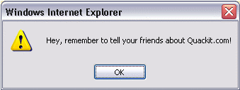

<input type="button"

onclick="alert('Hey, remember to tell your friends about Quackit.com!');"

value="Display Example" />

**Confirm**

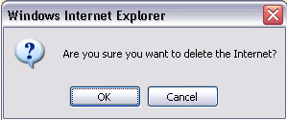

<input type="button"

onclick="confirm('Are you sure you want to delete the Internet?');"

value="Display Example" />

**Prompt**

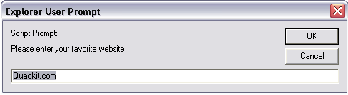

<input type="button"

onclick="prompt('Please enter your favorite website', 'Quackit.com');"

value="Display Example" />